Corporate Office Network Configuration
Report

Submitted to: Submitted by:
Sadaf iqbal
Sir Asad ul Haq Hashmi tehniat saqib

Network Design for Corporate Office

In this project, we design network system for the sub branch of the corporate office. Office has one buildings namely A have 3 portions.

Branch Design
Sub campus has one buildings:
- Building A
Floor 1: It has two departments namely Corporate office and Manager.
Floor 2: It has two departments namely IT and MARKETING.
Floor 3: It has one main Control Rooms.

NETWORK CONIGURATIONS:
Our network design will consist of three layers:
• Core layer having Routers.
• Distribution layer having Multilayer switches.
• Access layer having switches for end users to access.
Each department in the network is expected to be on its own separate IP network. The switches will be configured with VLANs. Inter VLAN routing will be used. We have used 1 Router to connect with 1 multilayer switch in our network. This 1 multilayer switch is then connected to 4 switches further.
All these routers, multilayer switches, switches, PCs are connected through Straight through cable.

ORGANIZATION REQUIREMENTS:
Building A: Floor 1
Department | Requirement | Implementation
Corporate office | 4 PC, 3 Laptop | 3 PC, 1 Laptop
Manager | 4 PC, 3 Laptop | 3 PC, 1 Laptop

Building A: Floor 2
Department | Requirement | Implementation
IT Department | 4 PC, 3 Laptop | 3 PC, 1 Laptop
Marketing Department | 4 PC, 3 Laptop | 3 PC, 1 Laptop

Building A: Floor 3
Department | Requirement | Implementation
Control Room | All controls | Access point, DNS server, 1PC

LIST OF IP ADDRESSES USED:
Sr. No | Department | IP Address | Default Gateway | Subnet Mask
 | Corporate  office | 192.168.10.11 | 192.168.10.1 | 255.255.255.0
 |  | 192.168.10.12 | 192.168.10.1 | 255.255.255.0
 |  | 192.168.10.13 | 192.168.10.1 | 255.255.255.0
 |  | 192.168.10.14 | 192.168.10.1 | 255.255.255.0
 | Manager | 192.168.20.11 | 192.168.20.1 | 255.255.255.0
 |  | 192.168.20.12 | 192.168.20.1 | 255.255.255.0
 |  | 192.168.20.13 | 192.168.20.1 | 255.255.255.0
 |  | 192.168.20.14 | 192.168.20.1 | 255.255.255.0
 | IT | 192.168.30.11 | 192.168.30.1 | 255.255.255.0
 |  | 192.168.30.12 | 192.168.30.1 | 255.255.255.0
 |  | 192.168.30.13 | 192.168.30.1 | 255.255.255.0
 |  | 192.168.30.14 | 192.168.30.1 | 255.255.255.0
 | Marketing | 192.168.40.11 | 192.168.40.1 | 255.255.255.0
 |  | 192.168.40.12 | 192.168.40.1 | 255.255.255.0
 |  | 192.168.40.13 | 192.168.40.1 | 255.255.255.0
 |  | 192.168.40.14 | 192.168.40.1 | 255.255.255.0

BUDGET:
Cisco Devices
Sr. No. | Device Name | Model | No. of Devices | Total Amount
 | Router | 4331 | 1 | 130000
 | Core Switch | Catalyst-3650 series | 1 | 380000
 | Switch | WSC-2950 | 7 | 90000
 | DNS server | PNR-12 | 1 | 400000
 | Access Point | Aironeto-Wave 2 | 1 | 220000
 |  |  |  | Total amount=1,220,000

CISCO PACKET TRASER SNAP
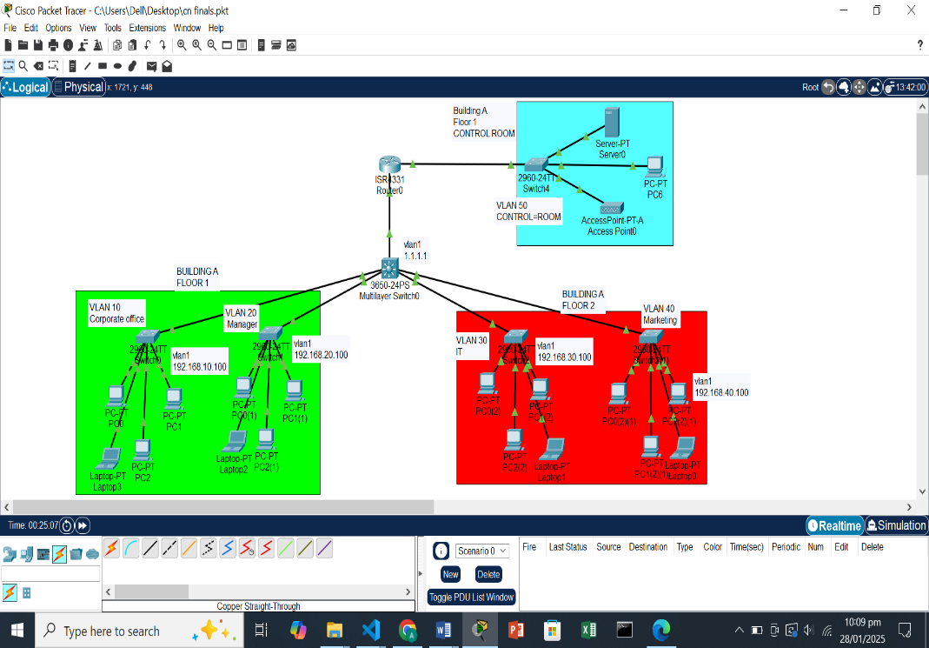
Different System Response:
